DMSF

Document Management System “Features”
User's guide

2.0.0 Karel Pičman 2019

CONTENTS
1 Introduction 3
2 Features 3
3 Requirements 3
4 Installation 3
5 Rake tasks 4
5.1 Convert documents 4
5.2 Alert approvals 4
5.3 Creating missing checksums for all document revisions 4
5.4 To maintain DMSF 4
6 Administration 5
6.1 Plugins 5
6.2 Custom fields 6
6.3 Roles and permissions 6
6.4 Approval workflows 7
7 Project settings 7
7.1 Modules 7
7.2 DMS 7
7.3 Approval workflows 7
8 DMS module 9
8.1 Documents 9
8.1.1 Documents management 9
8.1.2 New folder 9
8.1.3 Folder permissions 10
8.1.4 List of folders 11
8.1.5 Filtering 11
8.1.6 Tagging 11
8.1.7 Download 12
8.1.8 E-mail 12
8.1.9 Delete folder 13
8.1.10 Add documents 13
8.1.11 Update documents 14
8.1.12 Edit documents 14
8.1.13 Documents links 15
8.1.14 List of documents 16
8.1.15 Document details 16
8.1.16 Notifications 17
8.1.17 Approval workflow 18
8.1.18 Trash bin 21
8.1.19 Personal settings 21
9 Activity module 22
10 WebDAV 23
11 REST API 24
12 Wiki macros 24

Introduction
Document Management System “Features” - DMSF is a plugin for Redmine issue tracking system. It is aimed to replace current Redmine's Documents module.
Redmine DMSF now comes bundled with WebDAV functionality: if switched on within plugin settings this will be accessible from /dmsf/webdav. WebDAV functionality is provided through DAV4Rack gem.
Initial development was for Kontron AG R&D department and it is released as open source thanks to their generosity.
Redmine Document Management System "Features" plugin is distributed under GNU General Public License v2 (GPL).
Redmine is a flexible project management web application, released under the terms of the GNU General Public License v2 (GPL) at http://www.redmine.org/
Further information about the GPL license can be found at http://www.gnu.org/licenses/old-licenses/gpl-2.0.html#SEC1

Syntax
In this document the following syntax is used:
Italics – name of a company or product
Bold italics – links, click-able items
Bold – names of tabs, or fields you can fill in
Courier – commands

Features
- Directory structure
- Document versioning / revision history
- Email notifications for directories and/or documents
- Document locking
- Multi (drag/drop depending on browser) upload/download
- Multi download via zip
- Direct document or document link sending via email
- Configurable document approval workflow
- Document access auditing
- Integration with Redmine's activity feed
- Wiki macros for quick content linking
- Full read/write webdav functionality
- Optional document content fulltext search
- Documents and files symbolic links
- Document tagging
- Trash bin
- Compatible with Redmine 4.0.x

Requirements
Redmine 4.0.0 or higher
Xapian for full-text search support (optional)

Installation
Nothing special. Just follow common steps for Redmine plugins installation. Please see the README.md file in the root folder of the plugin.

Rake tasks

Convert documents
Convert project documents from the original Redmine Documents module to DMS folder/file structure. Converted project must have Documents and may not have DMS module activated.

Available options:
project => id or identifier of project (defaults to all projects)
dry => true or false (default false) to perform just check without any conversion
invalid=replace => to perform document title invalid characters replacement for '-'

Example:
rake redmine:dmsf_convert_documents project=test RAILS_ENV="production"

Alert approvals
Alert all users who are expected to do an approval in the current approval steps.

Example:
rake redmine:dmsf_alert_approvals RAILS_ENV="production"

Creating missing checksums for all document revisions
Create missing checksums for all document revisions. Optionally you can replace old MD5 with new SHA256 ciphering.

Available options:

dry_run => test, no changes to the database
forceSHA256 => replace old MD5 with SHA256

Example:

bundle exec rake redmine:dmsf_create_digests RAILS_ENV="production"
bundle exec rake redmine:dmsf_create_digests dry_run=1 RAILS_ENV="production"

To maintain DMSF

- Remove all files with no database record from the document directory
- Remove all links project_id = -1 (added links to an issue which hasn't been created)

Available options:

dry_run => No physical deletion but to list of all unused files only

Example:

rake redmine:dmsf_maintenance RAILS_ENV="production"
rake redmine:dmsf_maintenance dry_run=1 RAILS_ENV="production"

Administration

Plugins
There in the Redmine Administration under Plugins you can see something like that:

The plugin configuration is available by clicking on Configure. Available options are as follows (the default value in square brackets):

Maximum files upload [0] Limits maximum number of files uploaded at once. 0 means unlimited.
Maximum files download [0] Limits maximum number of files downloaded in zip or sent via email. 0 means unlimited.
Maximum email attachment size [0] Limits maximum file size that can be sent via email. 0 means unlimited. Number is in MB.
Maximum file size upload-able via AJAX [100] Maximum file size upload-able via AJAX
File storage directory [/files/dmsf] Where the uploaded files will be physically stored.
Physical file delete [No] Whether files are physically deleted after their deletion in the web interface.
File default notification [Deactivated] Allows set notifications per project.
Display notified recipients [Deactivated] When activated the user will be informed about all recipients of just sent the email notification.
Title format [‘’] Title format used when a document is dowloaded.
Act as attachable [No] Allows to attach documents to objects, e.g. issues.

Columns You can select which columns will be visible in the main document view. (All custom fields are available as columns)

From An email address from which are sent emails with documents.
Reply-to An email address for reply-to fiels when document are sent by email.
Links only Send links onlt instead of documents.

Keep documents locked Documents will be kept locked when approved.

WebDAV [Activated] WebDAV once enabled can be found at http://.../dmsf/webdav/[project identifier]
Webdav strategy [Read-only] Enables the administrator to decide if WebDAV is a read-only or read-write platform for end users.
Ignored files patterns A regular expression with file names pattern which will be ignored by PUT requests.
No versioning files patterns A regular expression with file names pattern which won’t be versioned by PUT requests.
Use project name for project folder [No] Use project names instead of project’s identifier for project folders.

Directory containing Xapian databases [files/dmsf_index] A location of Xapian full-text searching database.
Stemming Language [english] A language used for stemming.
Stem strategy [Stem none] This controls how the query parser will apply the stemming algorithm. The default value is STEM_NONE. The possible values are:
STEM_NONE: Don't perform any stemming.
STEM_SOME: Search for stemmed forms of terms except for those which start with a capital letter, or are followed by certain characters, or are used with operators which need positional information. Stemmed terms are prefixed with 'Z'.
STEM_ALL: Search for stemmed forms of all words (note: no 'Z' prefix is added).
Note that the stemming algorithm is only applied to words in probabilistic fields - boolean filter terms are never stemmed.

Custom fields
Custom fields can be applied on documents and folders. There in the Redmine Administration is an item Custom field. If New custom field from the command toolbar is selected, there is a new DMS type available. Then there is a common New custom field form where can be specified a new custom field parameters.
In order to use Documents tagging feature let's add a new DMS custom field named Tag as a list with possible values specified according to your requirements.
DMS adds an extra option Not inheritable to custom fields. If set, new revision of the document doesn’t inherit the value from the previous revision.

Roles and permissions
Available permissions:
View downloads in Activity stream Downloads will be available on Activity tab.
View revisions in Activity stream New revisions will be available on Activity tab.
Browse documents Documents are visible.
User preferences DMS tab is enabled in the project settings
View documents Documents can be downloaded, copied and moved. Approval workflow is available.
Email documents Documents can be sent by email.
Folder manipulation Folders can be created, deleted, edited, locked, unlocked. Email notification can be switched on/off.
File manipulation Documents can be uploaded, locked, unlocked. Email notification can be switched on/off. Approval workflows can be applied. Symbolic links can be created/deleted.
Delete documents It allows enter the trash bin and delete/restore documents.
Force file unlock A member is allowed to unlock a document locked by someone else.
File approval Enable/Disable document approval workflow approving.
Manage workflows Approval workflow tab is enabled in the project settings. Members are allowed to define approval workflows of the project.
Display system folders System folders are visible among other folders.

Approval workflows
The last Administration item related to DMS is Approval workflows. Here can be defined global approval workflows available in all projects.

Project settings

Modules
I order to be DMS available it is necessary to have checked the corresponding module in the Modules tab.

DMS
Each project member with corresponding permissions can set email notifications related to DMS documents and folders of the project.

Approval workflows
Definition of approval workflows of the project.

This tab allows project managers to define approval workflows.
- The approval workflow feature as a part of Document Management System allowing users to create an approval chain for document approving.
- An approval workflow is defined by a logical name and by assigned users – approvers in a particular order with a given dependency.
- Each approval workflow consists of one or more approval steps.
- Each approval step includes one or more approver and their dependency. It means that we can assign a new user with a dependency AND or OR. So to proceed to a next approval step it is required an approval by one or all approvers. Consequently we are able to define serial or parallel workflow this way.
To create a new approval workflow click on in the top right corner. Then you are expected to enter a name of the new approval wokflow:
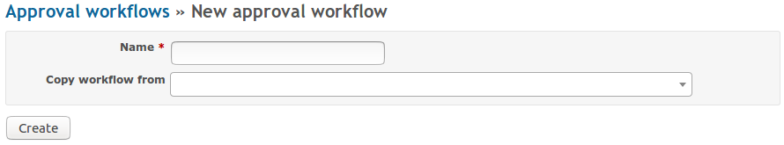
Now fill in a new workflow name and click on Create button.
Optionally you can select an existing approval workflow to be copied.
Just created workflow appears on the workflow list. In order to change the workflow name or to define workflow steps click on the workflow name. In our case on the text Basic.
Then workflow update form appears:

In the top of the form you can update the workflow name. Edit the name there and click on Save button.
Using the New step button you can choose one or more approvals and by clicking on AND or OR button you will add a new approval step to the end or by choosing an existing step from the list to an existing step.
Later on exiting approval steps can be removed, reordered or edited by clicking on corresponding icon next to the step approvals.
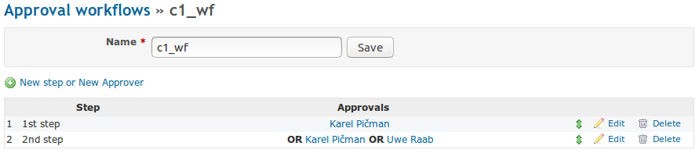
Examples
Adding a new step with a single approver
- Select a user from the list.
- Step value remains on its default value New step.
- Add a new approval step by clicking on the button ADD.
Adding a new step with more than one approver
- Select two or even more users from the list.
- Step value remains on its default value New step.
- Add a new step by clicking on the button AND or OR depending on the relation of approvers in the step.
Adding a next approver into an existing step
- Select a user from the list
- Change Step value to the number of an exiting step.
- Add a new step by clicking on the buttons AND or OR depending on the relation of the new approver in the step.
Approval workflow constrains
Deleting of an already used approval workflow causes that the affected documents remain in their last approval state: Assigned, Waiting for approval, Approved or Rejected but it is impossible to continue in an unfinished workflow. The approval log is also unavailable. Documents with the unfinished workflow remain locked. In order to reassign the workflow or in another way to update the document it is necessary to unlock the document first and then to create a new revision of the document either by uploading a new version of the document or by creation of a new revision in the document details.
In case of removing one of the steps of a particular workflow, the affected documents remain in their last approval state: Assigned, Waiting for approval, Approved or Rejected. If there are unfinished approval steps, it is possible to continue in the approval chain. The missing step is skipped. If the document is in the state Waiting for approval and the just removed step was the last approval step, the document remains in the state Waiting for approval and it is impossible to continue in approving.
In case of adding or reordering one or more approval steps into a particular workflow, the affected documents remain in their last approval state: Assigned, Waiting for approval, Approved or Rejected. The added steps are not included into already assigned workflows and therefore have no influence on assigned approval workflows. The updated workflow is reflected by documents with workflow assigned after the update.

DMS module

Documents
The Documents module allows you to store all documentation relevant to a project at one place, sorted into folders. You can switch on the Documents module by going to the project Settings → Modules tab. Check the check box in front of the DMS item, which is the Document Management System Feature.
At the screen you find two major areas: folder and files tree in the upper part of the screen, and an area for uploading files in the lower part of the screen.

Documents management
The documents are stored in folders, which should have such a structure that provides an easy orientation within the topic.


New folder
You can create a new folder by clicking the green plus sign in the right upper corner. This takes you to the following screen:


Type the new folder Title and select which already existing Folder it should belong to (the new folder will become a sub-folder of the selected folder). You can add a description of the folder. You can use various types of text formatting, such as headings, lists, links to web pages, documents etc. If you need help with the text formatting, click the Help tool button and you are provided with a list of commands, including examples.

When you are satisfied with the settings, click the Create button.

A new folder can be also created by copying an existing folder. Go to the folder you wish to create a copy of, and click the Edit icon:

Or click the edit button directly in the main view:

On the folder edit page click the Copy icon:
Select the Target project and Target folder. Click the Copy button.

Folder permissions
In the new folder form or later in the edit form you can specify an extra folder permissions. By selecting roles and members you can control access to the folder.

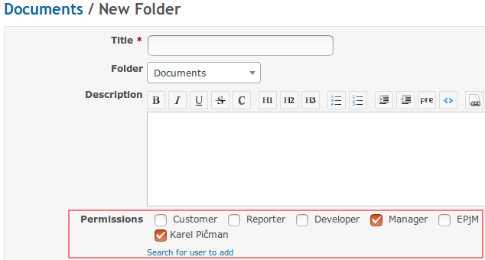
In the example above only Karel and members of Manager role will be permitted to access the folder.

List of folders
Each line of the folder list contains:
- the folder name
- number of files the folder contains
- folder size, date of creation, version, author
- folder edit tools
- possibility to erase a folder
- notification flag or

The editing tool uses the same form as is used for creating a new folder. You can change the folder title and description here and make it a sub-folder of a different folder.
You can sort the folders in the alphabetical or reversed alphabetical order. You achieve this by clicking the sign of arrow right from the column name (unsorted, alphabetical order, reversed alphabetical order):

Filtering
If you are unsure of what the name of the folder is, you can try applying a key word. Go to the Filter field, located in the right upper corner, and begin to type the key word.
Only those folders with titles that contain the given sequence of letters will be displayed. As you continue typing, less folders remain.

Tagging

There is a pre-defined list of tags. If you select a tag from the list, there will be displayed documents and folders marked with that tag only. To clear the tag filter and to display all documents and folders again just select the empty item on the list.

Download
Let's say you want to download all contents of a folder called “Training”. Check the check box in front of the folder title and then click the Download button (in the left upper corner):


The whole content of the folder will be zipped into one file and saved on your hard-drive.

E-mail
You can e-mail the folder content to your partner. Check the check box in front of the folder title and then click the Email button.


All contents of the folder will be zipped into one file. You will be asked to fill in the recipient's e-mail address, subject and you can add a piece of text explaining what are you sending. The zipped files are included automatically. However, be careful with sending the whole content of a folder as its size can exceed the e-mailing limits and your e-mail may not be delivered!
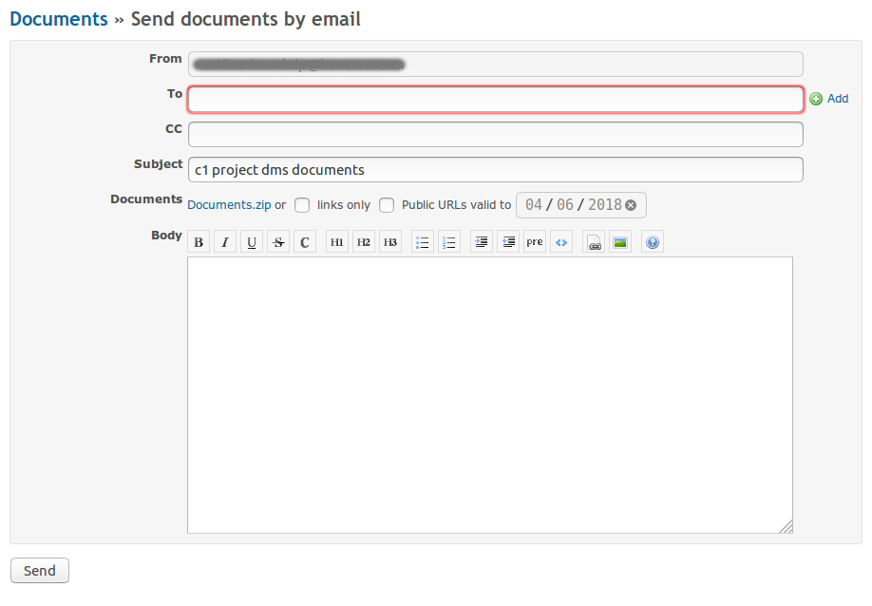
Before sending you can check the attachment by clicking on the URL link Documents.zip. .Alternatively you can select the option links only and send just links to documents and folder, which will be listed in the email body. Or, even you can make the document links public by selecting this option and entering the due date of the links validity.
Recipients can be selected from the project member list using next to To field.

Delete folder
You can erase a folder in two ways:
- click the red cross that is located at the end of the line containing the folder title
- check the check box in front of the folder title, then click the Delete button


Add documents
Once you have your folder structure set up, you can start filling it with files. You can, of course, add a new folder any time later.
New files can be added in three ways:
- Using drag & drop method – you drag & drop the files you wish to add into the area called Upload.
- Click the Add Files button, located left under the update area, then browse for the file.
- Switch from Modern to Classic in the top right corner of the upload area and use a classic upload form.
You see a list of all ready-to-be-added files. Each line contains:
- the name of the file,
- status,
- file size,
- possibility to remove the file from the list .

You can add up to 20 files within one upload. For files over 2GB you need to have a 64b browser. If you don't have a 64b browser, use you archiving tool such as ZIP or RAR and compress and then split your original file into more smaller archives before uploading. When all the files are ready for upload into the folder, click the Start Upload button. You will see the upload status changing. If needed, you can stop the upload by clicking the Stop Upload button.
You can adjust the area size by dragging the bottom line up and down.
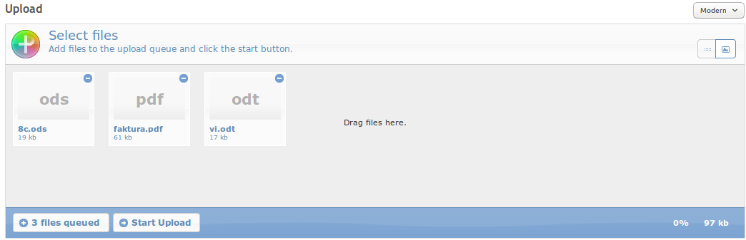

When the files are uploaded, a similar screen appears:

Here you can change the file title, add description and comment and assign an appropriate version. You can also select a corresponding tag from the pre-defined list. When satisfied, click the Commit button.
New content field supports Drag&Drop.
If a document of the same file name already exists in the current folder you are offered with a new revision of the document automatically.

Update documents
Go to the list of documents and find the document you want to update. Click the icon (details) and then, at the top of the page, click the + sign next to the “Create New Revision” title. A similar page will appear:

You can change the document title, adjust its description and/or comment. Browse for the updated file. Automatically, a new version will be assigned to it. It can be either a minor version (for example, if the previous version was 1.1, the new version will be 1.2; usually for minor changes in the document), or a major version (if the previous version was 1.x, the new version will be 2.0; usually for larger changes in the document). A custom version can be set optionally.
If you wish to change the document work-flow, but not to change the document itself, you do not add any new file. You do this, for example, when you have a document waiting for approval and you, as the responsible person, accept it. Then you can change the document state from Waiting for approval to Approved without making any changes to the document. You add a new revision, select the same version and Approved for the work-flow. You do not add any document.
When satisfied with all document settings, click the Create button and a new revision is added.

Note:
The same effect you can achieve by uploading an updated document to its original location. A new revision of the same document is created automatically after uploading.

Edit documents
Using a context menu you can click Edit and the document is open in an associated application. If the application supports documents online editing and WebDAV is enabled in read/write mode, you can edit directly documents this way.
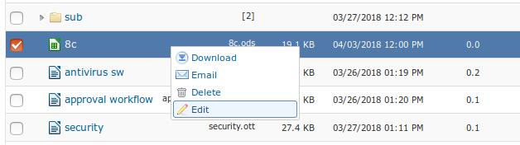

Documents links
There is possible to create a link to another document or folder from the same or another folder of the same or another project. Links behave as if operating directly on the target document or folder. It means for example that if you download or email a link, the referenced file is sent to the user.
If the target document is going to be removed or moved the user will be warn about existing links and these links will be automatically removed.
Create a link in the current location to another file or folder
There is a command in the command toolbar in the document or folder details form. After a click on that icon a new form New document link appears. The user is expected to choose a source project, folder and optionally document as the target of the link just being created.
Internal
Allow to create links to DMS objects.

External
Allow to create links to external object using their URL.

Create a link from the current file or folder to another folder
There will be a new command in the command toolbar of the main view. After a click on that icon a new form New document link appears. The user is expected to choose a target project and folder where the link just being created will be located.


List of documents
Your files are added into the folder:

You see the file titles and names, their size, last modification date, version, workflow state and who added them (the author). You can sort the list according to the individual columns by clicking the arrow next to their name (Title, Size, Modified, Ver., Workflow, Author). Furthermore, you can lock or delete files.

Symbols and their meaning:
- file details
- lock to prevent changes for other members
- unlock to allow changes for other members
- delete file
- locked file
- notifications not active: activate (Project Manager or Administrator only)
- notifications active: deactivate (Project Manager or Administrator only)
- approval workflow not assigned: assign
            - approval workflow assigned: start
      - waiting for approval: approve

Document details
If you click the symbol, you get to the page with detailed information about the file.
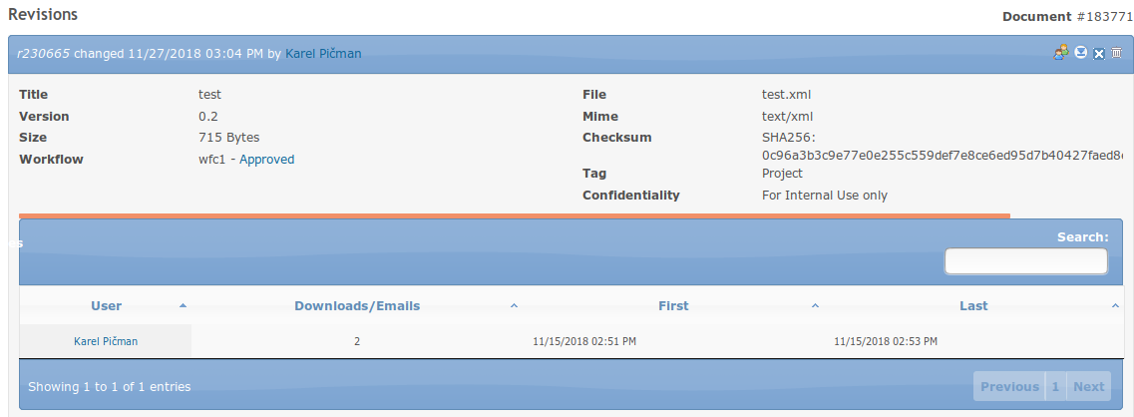
You see the file history, its versions and workflow. You can download older revisions by clicking the corresponding sign. You can show/hide download and email entries by clicking the icon. You can delete a particular revision by clicking on icon . The file can be copied or moved to another folder or even project by clicking on icon. A revision can be marked as obsolete with . Then you are expected to select a target folder and project. The file is copied or moved by a click on a corresponding button Copy or Move.

As a project manager you also see statistics about who, when and how many times has downloaded individual versions.
You can add new revision by clicking the plus + sign next to the New Revision title at the top of the page. Following screen appears:
You can change the title, description and add a new comment. If you add a new file (New content), a new version will be automatically assigned to it. It can be either a minor version (if the previous version was x.1, the new version will be x.2; usually for minor changes in the document), or a major version (if the previous version was 1.x, the new version will be 2.0; usually for extensive changes in the document).
When you finished all document settings, click the Create button and a new revision is added.

Notifications
It is possible for the Project Manager or the Administrator to enable/disable notifications for each document or document folder. If the notification flag is on, a notification e-mail is sent to all e-mail recipients after the document state has changed (creation, change, approval). The e-mail recipients are taken from the list of the project members. E-mail notification settings of individual users are taken in account.
If the notification flag is set on a folder, notification e-mails are sent if any document state changed within the folder sub-hierarchy.

Approval workflow

The approval workflow state is indicated by workflow status in the Workflow column and by corresponding icon on the very right side. The initial state is None as it is shown by the second document on the picture above. If you move your mouse cursor over an icon or text, a help text in a bubble is displayed. In case of the command icon it is the action represented by the icon state. In case of the workflow state there are listed next approvers.



You can check your open approval workflows on My Page Using the command icon on the right side you can approve documents directly from here. If the icon is missing, it means that you are not expected to do an approval in the current approval step.
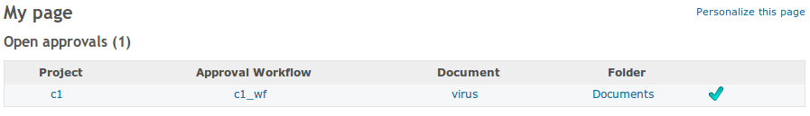
Approval workflow process
The process itself is clearly described on the diagram below.


And now step by step:
1. Assign an existing approval workflow to the selected document by clicking on the icon .Then a workflow assignment form appears:
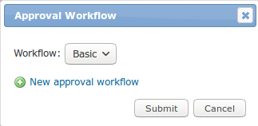
All project and global approval workflows are selectable. To manage approval workflows, see Chapter 7.3 Approval Workflow of Project settings. Select a workflow and click on Submit button. The selected workflow is assigned to the document. The icon has changed to.
2. In the next step the assigned workflow must be started by clicking icon.
3. When the workflow is started, all approvers in particular steps are expected to do an approval. The icon is changed to and the document is locked to prevent all changes.
If you are one of the approvers of the current approval step, the icon is click-able and you can do an approval by clicking on it. Then the approval form appears:

You have three options here, either approve, reject or delegate the current approval step. In case of rejection or delegation you are obliged to comment it in the text field “Your note...”. Only members of the project are offered for delegation. Your decision will be confirmed by clicking the Submit button.
4. If you has just approved the document and you are the last person of the approval chain. The document is approved as a consequence of your approval. The status is changed to “Approved”.
5. If you has just rejected the document. The approval chain is finished immediately and the document is in the state Rejected.
6. If you approve it and you are not the last approver or you delegate your approval to someone else, the workflow approval continues.
Approved an rejected documents remain locked depending on the plugin’s settings.
Log
All workflow approvals are stored and are available in the log window. You can open the window by clicking the workflow status text:

Email notifications
Email notifications are sent according to the table as follows:
Event | Receiver(s)
The approval workflow is started | All approvers of the first step
An approval workflow step is finished | All approvers of the next step and workflow owner
The document has been approved | All members of the project
The document has been rejected | All participants of the workflow and the workflow owner
An approval step has been delegated | The delegate
Due date has been reached | All approvers in the given step who haven't approved yet. These notifications are resent every working day.

Retrieving/Reassigning of an approval workflow
In case of a wrong approval workflow assigning or a need to restart the workflow, just add a new empty revision from the document details. Then you can assign a new approval workflow to the document. The approval workflow is always related to the last document revision.

Trash bin
If documents or folders are deleted by a user, they are moved into the Trash bin only in fact and can be restored again or definitively removed from the Trash bin with Delete documents permission.
The Trash bin is available from the main DMS menu:
The user interface of the Trash bin is very similar to the documents view except command icons. New command icons for restore and delete a folder or document are next to the deleted folders a documents. Once a document or folder is deleted from the Trash bin there is no way back!


Personal settings
Every project member is allowed to customize the DMS module behavior as follows:
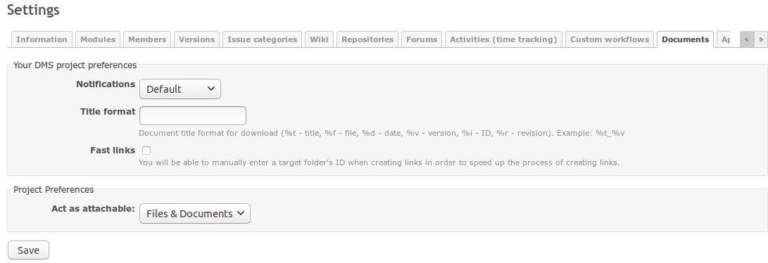
There are two options:
Notifications – Activated(default), Deactivated – If deactivated, you won't receive any email notifications related to documents and vice versa.
Title format – File names of downloaded documents can be formated using following tags:
%t – document title
%d – the date when the document was uploaded
%v – version of the documentation
%i – ID number of the document
%r – revision number of the document
Fast links – If selected, you are expected to enter a document’s ID instead of selecting the document from a pick list when creating a document link.
Act as attachable
Files & Documents – You can attach Files and Document to issues.
Files – You can attach Files only to issues.
This feature provides a possibility to attach documents to issues. The new/edit issue form contains a Drag&Drop area for uploading documents. It’s also possible to link existing documents using the button Link from. Attached documents are stored in system folders visible from the user interface depending on permissions.
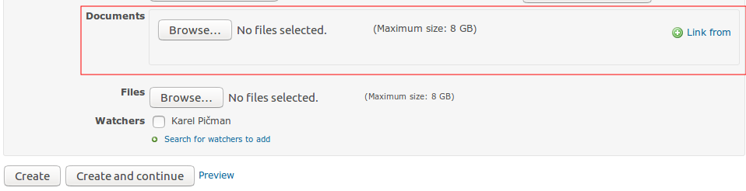
Tree view – In My account you can also switch on Navigate folders in a tree. Files and folder will be present as a hierarchical tree in the main view.
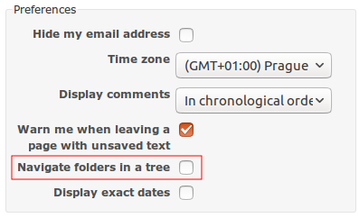

Activity module
All changes related to a file revision are recorded as activities.


WebDAV
The document module of the project can be mounted as a web folder. In a mounted folder is available a complete document and folder structure then. When a user does an operation such as download/upload a document or creating a new folder it is automatically recorded in DMS and it has the same effect as the operation would be done in the web interface of DMS.

In order to mount a project documents in MS Windows system open Documents, right click on the Computer item in the tree and select Mount network drive. Fill-in URL of the project documents module in the following format:
https://[your domain]/dmsf/webdav/[project identifier]
In the next step you are asked to login and in case of a successful login a new folder with the project documents appears.


REST API

DMS exposes some of its data through a REST API. This API provides access and basic CRUD operations (create, update, delete) for documents and folders. The API supports both XML and JSON formats.

Wiki macros
DMS offers several macros for referencing documents in wikis:
Documents:
  - {{dmsf(17)}} (Link to a document with id 17)
  - {{dmsf(17, File)}} (Link to a document with id 17 with link text "File")
  - {{dmsfd(17)}} (Link to the details of a document with id 17)
  - {{dmsfdesc(17)}} (Link to the description of a document with id 17)
  - {{dmsft(17, 5)}} (Link to the preview of 5 lines from a document with id 17)
  - {{dmsf_image(8)}} (An inline picture of the file with id 8; it must be an image file such as JPEG, PNG,...)
  - {{dmsf_image(8, size=300)}} (An inline picture with custom size)
  - {{dmsf_image(8, size=50%)}} (An inline picture with custom size)
  - {{dmsf_image(8, height=300)}} (An inline picture with custom height)
  - {{dmsf_image(8, width=300)}} (An inline picture with custom width)
  - {{dmsf_image(8, size=640x480)}} (An inline picture with custom size)
  - {{dmsftn(8)}} (A thumbnail with height of 200px)
  - {{dmsftn(8, size=300)}} (A thumbnail with custom size)
  - {{dmsfw(8)}} (Approval workflow status of a document with id 8)
Folders
  - {dmsff(5)}} (Link to a folder with id 5)
  - {{dmsff(5, Folder)}} (Link to a folder with id 5 with link text "Folder")

